 | Pokhara University  Everest Engineering College  Final Internal Assessment  Fall - 2025

Level: Master | F.M. 100
Program: ME Computer Engineering | P.M. 60
Faculty: Science & Technology | Time: 4hrs
Course: Data Structure and Algorithm Design

Attempt all the questions. Make assumptions where necessary.

1 | - Define circular queue. Write an algorithm to insert a new node at the end of doubly linked list.  - How does the Greedy Algorithm works? Construct an AVL tree for following sequence of elements: 5,10,15, 30, 25, 20, 4, 2,1. | 7  8
2 | - Describe the insertion process in a R-tree. Provide a step-by-step breakdown with an example set of points in a 2D plane.  OR  Describe the insertion process in a Point KD-tree. Provide a step-by-step breakdown with an example set of points in a 2D plane.  - Write an algorithm for Bellman-Ford algorithm. Find the shortest distance from source vertex (1) to other vertex using Bellman-ford algorithm.  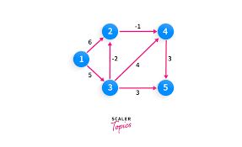 | 7  8
3 | - Use Kruskal’s algorithm to find the Minimum Spanning Tree (MST) for the following graph:  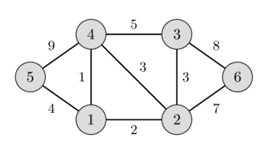  - Consider the following flow network: Vertices: {S, A, B, T} and Edges and capacities: (S, A, 10), (S, B, 10), (A, B, 2), (A, T, 8), (B, T, 9). Use the Ford-Fulkerson algorithm to find the maximum flow from source S to sink T. | 7  8
4 | - Store the following keys, K = {20, 33, 6, 45, 61, 11, 231, 90, 101} into the hash table using cuckoo hashing. Use hash function ℎ1(𝑘) = 𝑘 % 11 and ℎ2(𝑘) = 𝑘 % 13. Use both hash table size 15.  - Store the following keys, K = {12, 14, 17, 21, 24, 27, 31, 34, 37} into hash table using perfect hashing. Use primary hash function ℎ(𝑘) = 𝑘 % 𝑚 where E = 10 and secondary hash function ℎ_{j}(𝑘) = 𝑘 % 𝑚_{j} where 𝑚_{j} =n_{j}². | 7  8
5 | - Sort the following numbers using Radix Sort: 150, 35, 45, 80, 505, 24, 2, 76. Show the steps for each pass and the final sorted list. How can Radix Sort be made to work for a list of names (strings) of different lengths?  - Describe the Bitonic Merge Sort with suitable example. | 8  7
6 | - Explain the concept of dynamic programming. How does it differ from greedy algorithms? Provide an example to demonstrate how a problem is formulated and solved using dynamic programming.  - Given the following set of characters and their frequencies, construct a Huffman tree and derive the Huffman codes for each character: A: 7, B: 3, C: 15, D: 9, E: 16, F: 50. Show the steps. | 8  7
7 | Write short notes on: (Any two)  - Planar Graphs and its applications  - Cache-Aware vs. Cache-Conscious algorithms  - Principles of Cache-Efficient Data Structures | 2*5=10

